We here at Cornerstone CFCU understand the concern
for your personal information due to the Equifax breach.

As of 9.7.17, Equifax has stated that there is “No Evidence of Unauthorized Access to Core Consumer or Commercial Credit Reporting Databases”. Regardless, it may be in your best interest to understand or review the information Equifax has been issuing in response.

We’re sure you have questions. For answers, go to www.equifaxsecurity2017.com or call 1.866.447.7559. The call center is open every day (including weekends) from 7:00 a.m. – 1:00 a.m. Eastern time.

In addition to the Equifax Potential Impact website, Equifax will send direct mail notices to consumers whose credit card numbers (estimated at 209,000 people) or dispute documents (estimated at 182,000 people) with personal identifying information were impacted.

To see recommended courses of action the Federal Trade Commission has provided on the breach, please click here. If you would like to place a security freeze on your Equifax credit information, please visit www.freeze.equifax.com/Freeze and follow the instructions provided.

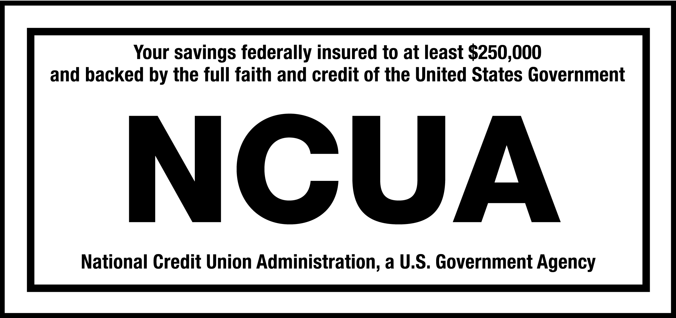
This is being provided for informational purposes only. Cornerstone CFCU is not making recommendations of action or inaction, it is important for you to consider what may be the best option for you.

