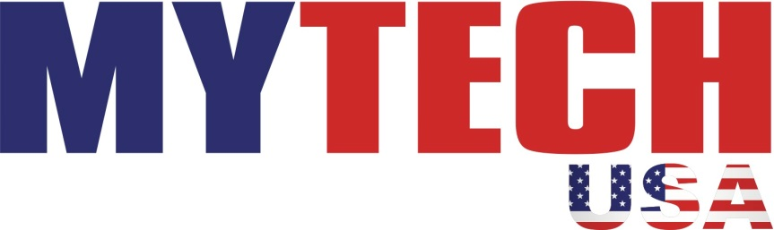

Cornerstone is pleased to announce that we have teamed up with MyTech USA to offer a new discount for our members. MyTech USA is an electronic center located in the Lockport and North Tonawanda Walmart stores. They repair devices such as phones, tablets and computers. With so many electronic devices these days, most of us have something that needs a repair! Some of their most common repairs are fixing cracked screens, unlocking phones, and removing viruses from computers.
If you pay for your repair using your Cornerstone CFCU debit or credit card, you will receive a 10% discount on your service. This benefit will help save you money and is available to all Cornerstone members immediately. As a special introductory bonus…the discount will be 15% through the end of July, 2015 only.
To learn more visit mytechusa.com. You can also call 438-3777 (Lockport) or 264-5701 (North Tonawanda).

